BIFS 614 – Data Structures and Algorithms
Week 8 Lecture – Introduction to linux, Part II: Bioinformatics in Bash

Last week you learned your way around the basics of Bash, the linux terminal. This week we’ll build on those skills and start working on bioinformatics data files using linux.

As we have discussed previously, many of the bioinformatics data files you will encounter are simply flat text files – meaning they have no complex structure (like a Word file). This means they are very easy to view and manipulate, and linux has some of the best tools for viewing and manipulating text files. Let’s start with some simple examples.

First, you'll want to download the sample file "sample.vcf" from the COURSE RESOURCES section of the classroom, then upload the sample file to your hosted linux. You can do this using the button at the top of the screen:



Pressing this will give you a series of buttons – one of which allows you to upload:



Place the sample.vcf file on your Desktop, then using the terminal navigate to the desktop:

cd Desktop

VIEWING FILES IN LINUX

Let’s take a look at what’s inside our file. Enter this command into the terminal:

head sample.vcf

The head command displays the first 10 lines of the file you list after the command. Note that the lines will wrap, so it might be a little hard to read. You can resize your terminal window to try to display the lines more clearly:

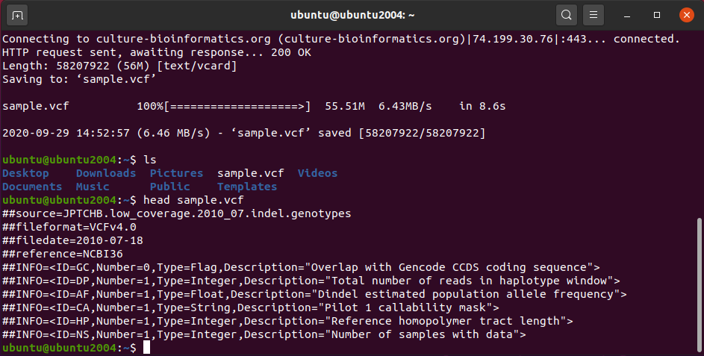

The head command isn’t limited to displaying the first 10 lines – for example, if we use the -n flag, we can tell it to display as many – or as few – lines as you like:

head -n20 sample.vcf

This tells head to display the first 20 lines of sample.vcf. When you do this you’ll see that you are now viewing more than just the headers (the lines starting with “##”) – and the data is very “messy” to read in the terminal because of the large number of columns. Still, the head command is useful to peek into a file and see the contents.

Equally useful is the tail command. As you may have guessed, the tail command displays the last 10 lines of the file, by default – and you can use the same flag (-n) to change this:

tail -n15 sample.vcf

My favorite use of the tail command is actually to watch a log file, or a data file, as it gets written to – you can monitor the new lines being added in real time. This isn’t something we’re going to do today, but if you’re curious, you can try added the -f (for follow) command to tail when you’re viewing a file that’s currently being written to.

So head and tail let us see the beginning and end of a file. We can also view the entire file all at once by using the cat command:

cat sample.vcf

When you enter the above command, the entire contents of the sample.vcf file go whizzing by in the terminal. It’s not the best way to read a large file, but it is a great way to send a file somewhere else – for example, if you want to merge two files, you would use cat to concatenate them into a new file:

cat file1 file2 > merged_file.txt

You can also use cat to send a file to another application for processing using the pipe symbol we learned earlier (“|”). But we’re getting ahead of ourselves – how can we more easily read a large file like sample.vcf? Let’s use the more command:

more sample.vcf

The more command displays the file one “page” at a time. This isn’t a standard page, it’s just sized to fill however large your terminal window is. To see the next page, you can press the SPACE bar, or to just display the next line, press RETURN. To exit, so that you don’t have to scroll all the way to the bottom of the document, press the “Q” button.

The more command is nicer than cat, but there’s another viewing command you should know, and that is less. Enter the following command:

less sample.vcf

Similar to more, less will display a the file one “page” at a time. What makes less nicer, however, is that in addition to allowing you to move to the next line with RETURN, or the next page with SPACE, you can use the up and down arrow keys to smoothly scroll up or down through the document. The “Q” button again exits the program.

EDITING FILES IN LINUX

There are as many ways to edit a file in linux as there are ways to view one. You can certainly use a graphical text editor like gedit or text editor, but in bioinformatics the majority of the time you are working you will be in the command line – for example, when you are connected to a remote server, like a supercomputer. So let’s use a command line text editor – my favorite is nano.

To begin, enter the following command:

nano sample.vcf

The sample.vcf files opens in the nano screen editor:
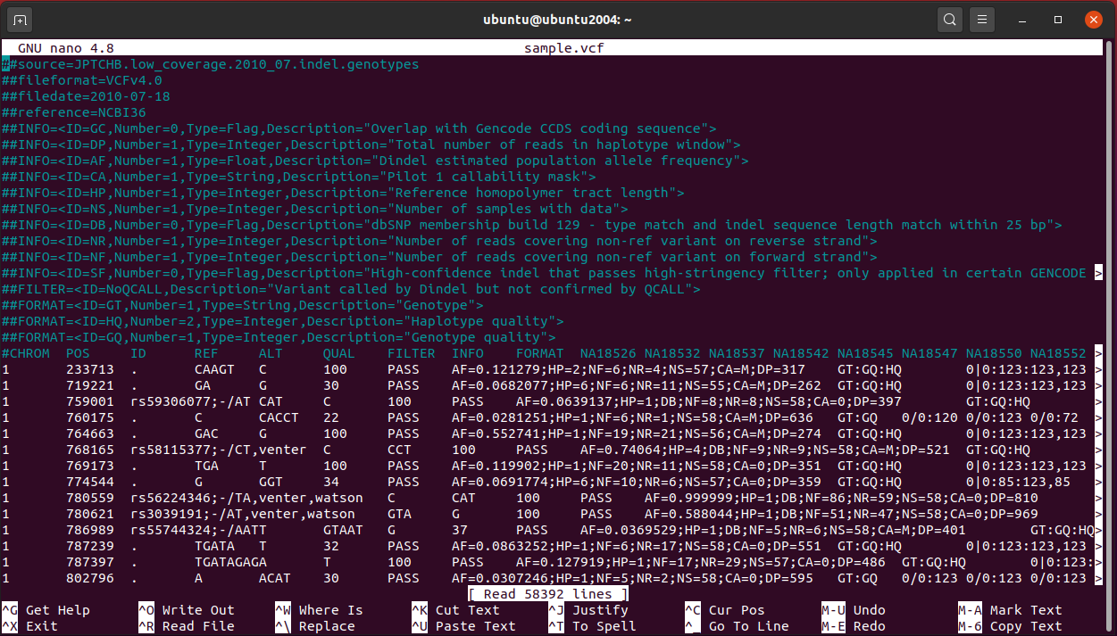

The nano editor is fairly easy to use, but it’s not quite like a word processor. To move the cursor to a different line – say where you want to make a change – you can use the arrow keys (all four – up, down, left, and right). Once the cursor is where you want it, simply start typing (or deleting, etc.). To exit out of the editor, you can use the CONTROL+X buttons (if you look at the bottom of the UI you’ll see that there are a series of commands that you can access using CONTROL plus some other key). The nano editor is powerful, but since all of the features require that you know the key combinations, you’ll just have to practice using it to get comfortable with all of them. Luckily you can “cheat” and use the manual – more on that later when we talk about the man command. For now, exit out of Nano and, if you made changes, do not save them.

PARSING FILES IN LINUX

The ability to write custom filter commands is what makes linux incredibly useful to bioinformatics. You’ve taken several looks at the sample.vcf file by now, so you’ve seen how complex it is – not just in terms of size, but the number of columns and their contents. There are three commands that we will use to make this data more manageable, and to pull out the interesting elements: grep, awk, and sed.

The grep command is used to search for global regular expressions – at it’s simplest you can use grep to just look for words and phrases, although it’s far more powerful than just a search.

Let’s do a simple example – let’s say you are looking for any mentions of a particular SNP (single nucleotide polymorphism) in your variant caller file – let’s say the SNP is rs56190854. You can use grep to search for it by name by typing this command:

grep rs56190854 sample.vcf

This command reveals that there is one line that contains that SNP ID in the entire file. It doesn’t look like one line because it wraps, but we can prove it by using another command that counts the number of lines in our output. First let’s clear the screen by using the clear command:

clear

Now let’s pass the results of the above grep command to wc -l, which is the counter:

grep rs56190854 sample.vcf | wc -l

Did you remember that you can use the up arrow to return to a previous command? If you use the up arrow to return to the original grep command, you can just add the additional terms and press return. This returns the value of 1, so there is just one instance of rs56190854! The wc -l command is actually the word count command using the “-l” flag to count lines instead of words. Very handy, isn’t it?

The grep command is useful for finding specific references to things. We can also use it to get the context of that item by telling it to return additional lines before and/or after the line containing our search term. If we enter this command:

grep -A4 rs56190854 sample.vcf

The “-A4” flag tells grep to include the 4 lines following the result (or results, if there are more than one). In a similar fashion you would use the “-B” flag to show additional lines prior to the match. And you can always do both:

grep -A1 -B1 rs56190854 sample.vcf

In the above examples we were looking for a specific item, and grep returned only that one item. However, if there had been a SNP ID that was identical to our query but longer, grep would have found both of them – e.g. rs561908547 would also have shown up (notice that it is the same but with one additional character, a 7, at the end). That’s because grep looks for the pattern, not the exact match!
Let’s test this by searching for something we know is represented multiple times:

﻿grep "INFO=<ID" sample.vcf

The “INFO=<ID” string is found multiple times. Note that we had to include the search term inside non-curly parentheses so that grep would not use the search characters as command terms!

Let’s do another example:

﻿grep "INFO=<ID=N" sample.vcf

This returns even fewer results, because we are narrowing our search down!

You can also use grep to return the inverse of your search – in other word, find every line that does not contain your result using the “-v” flag:

Lastly, we can use grep to search through not just a single file, but an entire directory of files:

﻿grep -v PASS sample.vcf

In this example we searched for lines that didn’t include “PASS”. What we saw returned were only the headers! The software that generated the .vcf file only included variations that passed their filter, so that is what we would expect.

NOTE: you have probably noticed by now that linux is case sensitive – for example, using a “-v” for a flag is very different from using “-V”, and if you had searched for “pass” instead of “PASS” in the above example you would have seen the entire file zip by – since “pass” isn’t present anywhere, only “PASS”.

Let’s move on to our next command, awk. The awk command is a powerful text processor that works really well with data tables, whether they are comma or tab-delimited. As you recall, many bioinformatics data formats are of this type, so you’ll be spending a lot of your time in awk. Unlike most linux commands, awk isn’t named for its function; instead the letters “a”, “w”, and “k” refer to the last names of the developers who wrote awk: Aho, Weinberger, and Kernighan.

Our sample.vcf file is a column-based file that is tab-delimited, which makes it a perfect data file to use awk on. If you recall, one of the header lines in sample.vcf told us what the column headers are. For our purposes today we’re only going to use the first 7, which are:

CHROM POS ID REF ALT QUAL FILTER

Let’s start by walking through what these columns mean. From the samtools VCF specifications (located at https://samtools.github.io/hts-specs/VCFv4.2.pdf) we have the following:

- CHROM - chromosome: An identifier from the reference genome or an angle-bracketed ID String (“<ID>”) pointing to a contig in the assembly file (cf. the ##assembly line in the header). All entries for a specific CHROM should form a contiguous block within the VCF file. (String, no white-space permitted, Required).

- POS - position: The reference position, with the 1st base having position 1. Positions are sorted numerically, in increasing order, within each reference sequence CHROM. It is permitted to have multiple records with the same POS. Telomeres are indicated by using positions 0 or N+1, where N is the length of the corresponding chromosome or contig. (Integer, Required)

- ID - identifier: Semi-colon separated list of unique identifiers where available. If this is a dbSNP variant it is encouraged to use the rs number(s). No identifier should be present in more than one data record. If there is no identifier available, then the missing value should be used. (String, no white-space or semi-colons permitted)

- REF - reference base(s): Each base must be one of A,C,G,T,N (case insensitive). Multiple bases are permitted. The value in the POS field refers to the position of the first base in the String. For simple insertions and deletions in which either the REF or one of the ALT alleles would otherwise be null/empty, the REF and ALT Strings must include the base before the event (which must be reflected in the POS field), unless the event occurs at position 1 on the contig in which case it must include the base after the event; this padding base is not required (although it is permitted) for e.g. complex substitutions or other events where all alleles have at least one base represented in their Strings. If any of the ALT alleles is a symbolic allele (an angle-bracketed ID String “<ID>”) then the padding base is required and POS denotes the coordinate of the base preceding the polymorphism. Tools processing VCF files are not required to preserve case in the allele Strings. (String, Required).

- ALT - alternate base(s): Comma separated list of alternate non-reference alleles. These alleles do not have to be called in any of the samples. Options are base Strings made up of the bases A,C,G,T,N,*, (case insensitive) or an angle-bracketed ID String (“<ID>”) or a breakend replacement string as described in the section on breakends. The ‘*’ allele is reserved to indicate that the allele is missing due to a upstream deletion. If there are no alternative alleles, then the missing value should be used. Tools processing VCF files are not required to preserve case in the allele String, except for IDs, which are case sensitive. (String; no whitespace, commas, or angle-brackets are permitted in the ID String itself)

- QUAL - quality: Phred-scaled quality score for the assertion made in ALT. i.e. −10log10 prob(call in ALT is wrong). If ALT is ‘.’ (no variant) then this is −10log10 prob(variant), and if ALT is not ‘.’ this is −10log10 prob(no variant). If unknown, the missing value should be specified. (Numeric)

- FILTER - filter status: PASS if this position has passed all filters, i.e., a call is made at this position. Otherwise, if the site has not passed all filters, a semicolon-separated list of codes for filters that fail. e.g. “q10;s50” might indicate that at this site the quality is below 10 and the number of samples with data is below 50% of the total number of samples. ‘0’ is reserved and should not be used as a filter String. If filters have not been applied, then this field should be set to the missing value. (String, no white-space or semi-colons permitted)

Let’s do some simple examples. Since awk lets you work on columns, we could, for example, find all variants on Chromosome 1 by taking advantage of the chromosome column:

﻿ awk '$1 == 1 {print $0}' sample.vcf

An awk command always has this basic form:

awk '<optional qualifiers>{<actions>}' filename.ext

In our example, we told awk that anywhere in the file sample.vcf that the first column ($1) had a value of 1, we should print the entire line ($0). You’ll notice that there were very many matches for chromosome 1, so let’s narrow our search down a bit by only looking at the half-million bases of chromosome 1:

awk '$1 == 1 && $2 < 500000 {print $0}' sample.vcf

In this example, we added a second qualifier and used the “&&” operator to combine them, meaning that both qualifiers had to be met. Let’s compare the two statements and see how the numbers changed using a trick we learned above – piping the output to wc -l:

awk '$1 == 1 {print $0}' sample.vcf | wc -l
awk '$1 == 1 && $2 < 500000 {print $0}' sample.vcf | wc -l

The first statement yields 66 lines; the second only 1.

Let’s do a different sort of example – let’s see how many of the variants that were called in this genomic analysis are the result of a “A” to “AG” mutation. From the description of the VCF format above, we know that the reference (expected) genomic value is stored in column 4, and the alternate (the variant that was detected) is stored in column 5. So this awk command should work:

﻿ awk '$4 == "A" && $5 == "AG" {print $0}' sample.vcf

We get several of this type of mutation – 4, to be exact. Let’s change it up a bit – instead of printing out the entire line, let’s just print out the chromosome number for this type of mutation:

awk '$4 == "A" && $5 == "AG" {print $1}' sample.vcf

The print command inside the curly brackets can do much more than print a complete line (which is what $0 is). In fact, we could even print out the chromosome and the position:

awk '$4 == "A" && $5 == "AG" {print $1, $2}' sample.vcf

Let’s do two more things – let’s output the above results to a file, and then let’s see if we can determine (without counting manually) how many of these mutations there are on each chromosome.

Creating a file from the terminal output is easy – we just use the “>”, or redirect, command:

awk '$4 == "A" && $5 == "AG" {print $1, $2}' sample.vcf > positions.txt

After running this command you’ll have a new file, positions.txt – use one of the commands you learned earlier to view this file before moving on.

Now let’s figure out how many ATG to A mutations there are in each chromosome. There are many ways to do this – we could even have added another qualifier to our original statement and used wc -l to find it, but since we created an intermediary file, let’s use that since it’s smaller:

awk '$1==1 {count++} END{print count}' positions.txt

This tells awk that whenever column one ($1) has a value of 1, increment the counter named count. We have to add an END statement to tell it that we are done, then the print command is used to print the value of the counter. When you run this command, you’ll see that there are 4 AG to A mutations on chromosome 1. Changing this to reflect the count on chromosome 2:

awk '$1==2 {count++} END{print count}' positions.txt

And the answer is 0.

We could have written this all in one line, piping the output of the original awk statement that created positions.txt to the awk statement that did the counting, adding separate variables for each chromosome, but I like using intermediate files – it makes checking for bugs and errors much easier.

There’s far much more you can do with awk – it can do mathematical operations within columns, so you could add or average values, but I’ll let you explore that on your own. Now let’s move on to the last of the parsing tools we’re going to talk about – sed.

The sed command is not so much a parser as it is an editor. In fact, sed stands for stream editor, because it works on an “input stream”, which is a fancy of way saying it will work on files or the output of other commands. Sed is useful when you need to search and replace within a document – which can let you reformat a document (e.g. replace tabs with commas or vice versa) or change the text to something more readable (e.g. replace “chr” with “chromosome”). You can also used sed to edit specific lines, whether they are indicated by a specific line number, their contents, or first/last lines etc.

Let’s do an example that you will probably use someday – converting a FASTQ file to a FASTA file. Recall from our earlier lectures that FASTQ files contain sequence data, just like FASTA files do, but with more information – the quality line – and different headers. We can use sed to reformat a FASTQ file so that it is a FASTA in just one line.

First, let’s obtain a FASTQ file. There’s a small sample FASTQ in the COURSE RESOURCES; you can transfer it to your linux system just like you did the sample.vcf.

If you like, use one of the tools you’ve learned above to take a look at the file and make sure it looks okay. Once you are done, try this command:

﻿sed -n '1~4p;2~4p' sample.fastq

In this command we used sed to print the 1st and 2nd line out of every group of 4 (1~4 is the first of every 4 and when combined with the “;” to 2~4 we also get the second line; the “p” tells sed to print them to the console). The “-n” flag tells sed not to print the pattern line (if you leave it out you’ll get duplicates of each line).

The FASTQ file is starting to look more like a FASTA – but the headers are very different, so we need to change those too. We can use the search and replace features of sed to do that:

sed 's/^@/>/g' sample.fastq

The search and replace syntax is pretty straight forward once you understand it. The basic battern is this:

sed 's/<text to find>/<text to replace it with>/g' file.ext

Simplified you can think of this as:

sed 's///g' file.ext

where you put the text to find between the first two slashes, and the text to replace it with between the last two slashes. The “s” tells sed you are performing a search/replace, and the “g” tells sed to make it global – in other words, search and replace through the entire document.

Our example above is a little more complex, however. Instead of just searching for “@”, we are searching for “@” only at the beginning of a line. That is what the “^” symbol is telling sed – find “@” at the beginning of the line. Why are we doing that? It turns out that the “@” symbol is also used in the phred quality symbol map, so we have to make sure we don’t accidentally replace all of the “@” symbols in the quality lines.

So our example, then, tells sed to find “@” at the beginning of a line and replace it with “>”, and to do it globally. Go ahead and run the command and see how the file looks now.

Our last step is to string those two commands together – the first one to remove the 3rd and 4th lines of each group of 4, and the second to change the header:

sed -n '1~4p;2~4p' sample.fastq | sed 's/^@/>/g'

Go ahead and run that – the FASTQ file now looks like a FASTA file! The only thing left to do is to save this output as a fasta instead of viewing it on the screen, so we can use the “redirect” command we learned earlier:

sed -n '1~4p;2~4p' sample.fastq | sed 's/^@/>/g' > sample.fasta

Between grep, awk, and sed, you have a series of powerful text file searching and editing applications. Given that the majority of bioinformatics data files are in fact text files, you will likely be spending a lot of time using these or similar tools.

If you’ve already learned some python, you will know that you can also do many of these sorts of manipulations in python – so why would we use the BASH terminal in linux to do so? The answer is easy – often it’s convenient to create a pipeline of analyses, and the easiest way to do that is BASH. For example, you may execute a python application, take the results of that and pipe them into another python application – or maybe a C or perl application. Linux BASH is the glue that can be used to create these pipelines, and if you need to tweak files between applications (e.g. renaming headers or changing the format), BASH can make it easy to do in the same script that pipes everything together.

BASH SCRIPTING

While we’re talking about it, let’s write a quick BASH script using some of the commands we’ve learned above. For example, we can write a script that converts FASTQ to FASTA – that way you won’t have to remember all of the commands or retype them every time. We’ll use my favorite editor, nano, to write the script. To begin, enter the following command:

nano fastq2fasta.sh

The file “fastq2fasta.sh” doesn’t exist, but nano is happy to create it for us if we tell it to. We are using the extension “.sh” to remind us that this is a shell script.

Now inside your nano editor enter these lines:

#!/bin/bash

# This program will convert a FASTQ file to FASTA format.
# To run it simply type bash fastq2fasta.sh <filename>

﻿sed -n '1~4p;2~4p' $1 | sed 's/^@/>/g' > $2

After adding this to the editor, press CONTROL+X – this tells nano that you want to save the file. It will ask you if you want to save the modified buffer (meaning file):

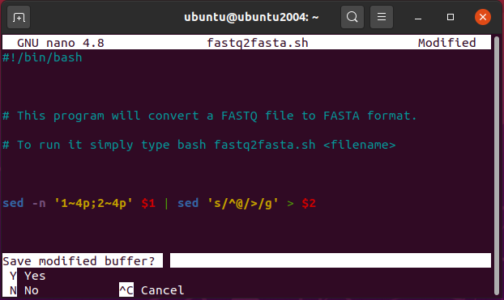

Press “y”, then RETURN to accept the default name to save the file. Now let’s walk through what this does, and how we can use it.

Lines that start with a “#” are comment lines – nothing is executed on those lines, they are just there so that you can leave yourself comments on what the program does. Comments are very important to add, so that anyone using your script later will be able to figure out what it does.

The exception to this rule is the first line – even though it starts with a “#”, the addition of the “!” tells linux that this line indicates what application should be run when it is launched. By telling linx “#!/bin/bash” we are telling it to use the BASH application, which is stored in the “/bin/bash” directory.

The last line is the actual conversion routine. It looks just like the line we used above, with one exception – instead of naming the input file (sample.fastq), the script uses “$1”. Notice that we also use something similar in the output file name – “$2”. In BASH, if you run a program and add terms after the program name, those terms are stored as variables. And, you guessed it, they are named in order – so if we run this program and list the input file and the output file names, it will give us exactly what we want. Let’s try it now. In the terminal window enter the following command:

bash fastq2fasta.sh sample.fastq new.fasta

Notice that we ran our BASH script by first typing “bash” then the filename. Since the file wants two variables names (the input file and the output file) we added “sample.fastq” as our input, and “new.fasta” as our output (using a different name than when we converted this earlier so that we can make sure our script works. If all went well, when you list the contents of the directory you should see the new.fasta file. Take a peek at it with more to see what it looks like.

On most linux systems, you wouldn’t be able to execute your new script unless you had told linux that it was an executable file. To do that you would type the following command:

chmod a+x fastq2fasta.sh

This uses the chmod, or change mode, command, to add execute privileges to everyone (that’s where the a+x comes in – all users, add execute privileges). You can do that to your script if you like.

There are many other useful commands in linux that you’ll want to use – there are commands to sort data (sort), take a file and eliminate redundant entries (uniq), compare two files to see where they differ (diff and comm), even a command to get instructions on how to use commands (man). Explore on your own – start by entering this command to see how to use sort:

man sort

